Screening Pharmakovigilanz-relevanter Webseiten
- Dokumentation -

EMA: What's New?
EMA: EURD-Liste / PSUR Worksharing
EMA: Additional Monitoring
EMA: Signale
PRAC: Agenden, minutes and highlights

CHMP: Committee meeting reports

HMA: What’ new?

EU-Kommission: Newly adopted Marketing Authorisation Decisions (last six months)

BfArM: Aktuelles (Bereich Pharmakovigilanz)
PEI: Aktuelles (Bereich Arzneimittelsicherheit / Vigilanz)

EMA: What's New?
http://www.ema.europa.eu/ema/index. jsp?curl=pages/news_and_events/landing/whats_new.jsp&mid=WC0b01ac058004d5c4
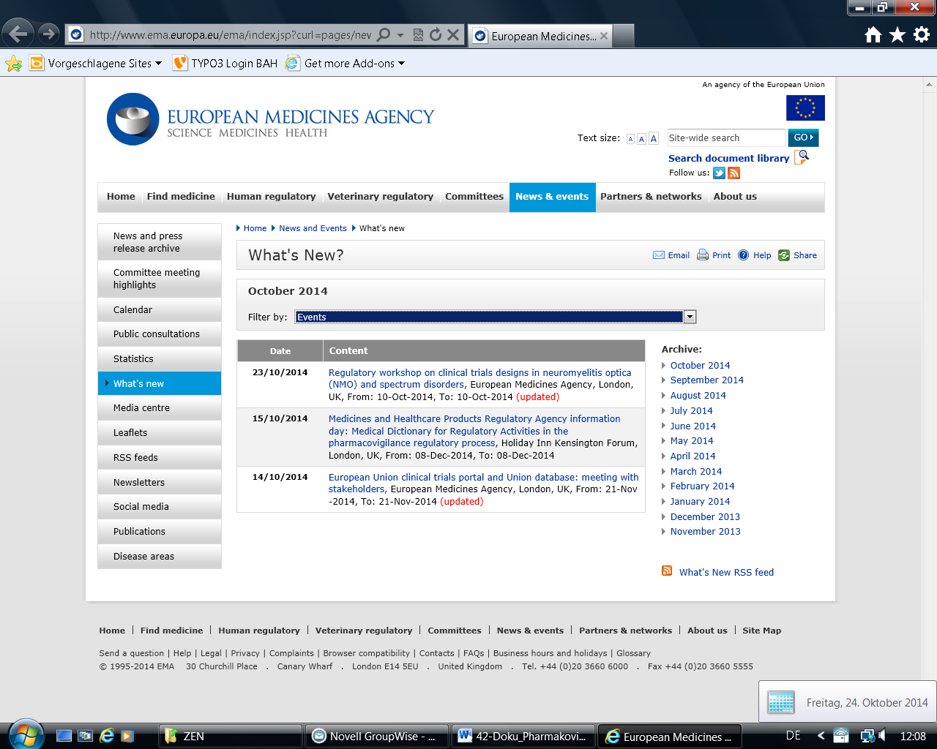
EVENTS

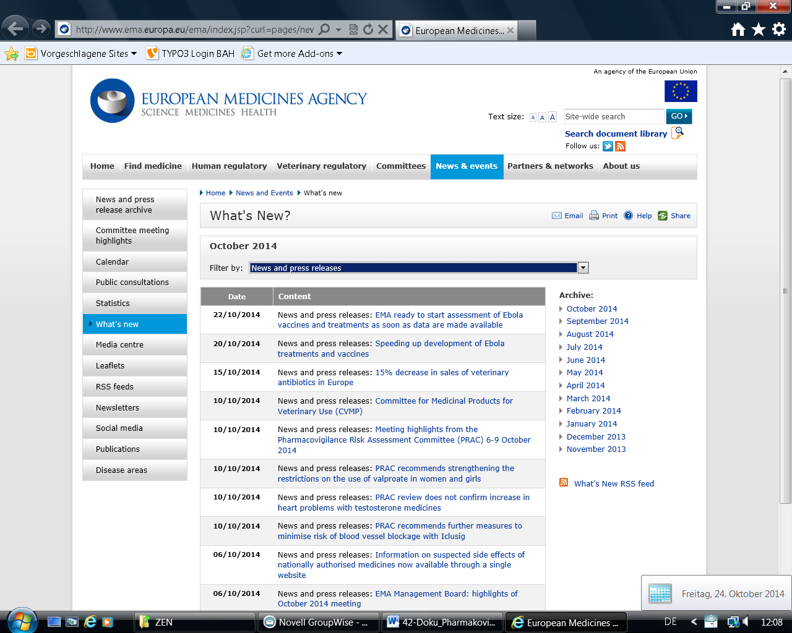
NEWS AND PRESS RELEASES

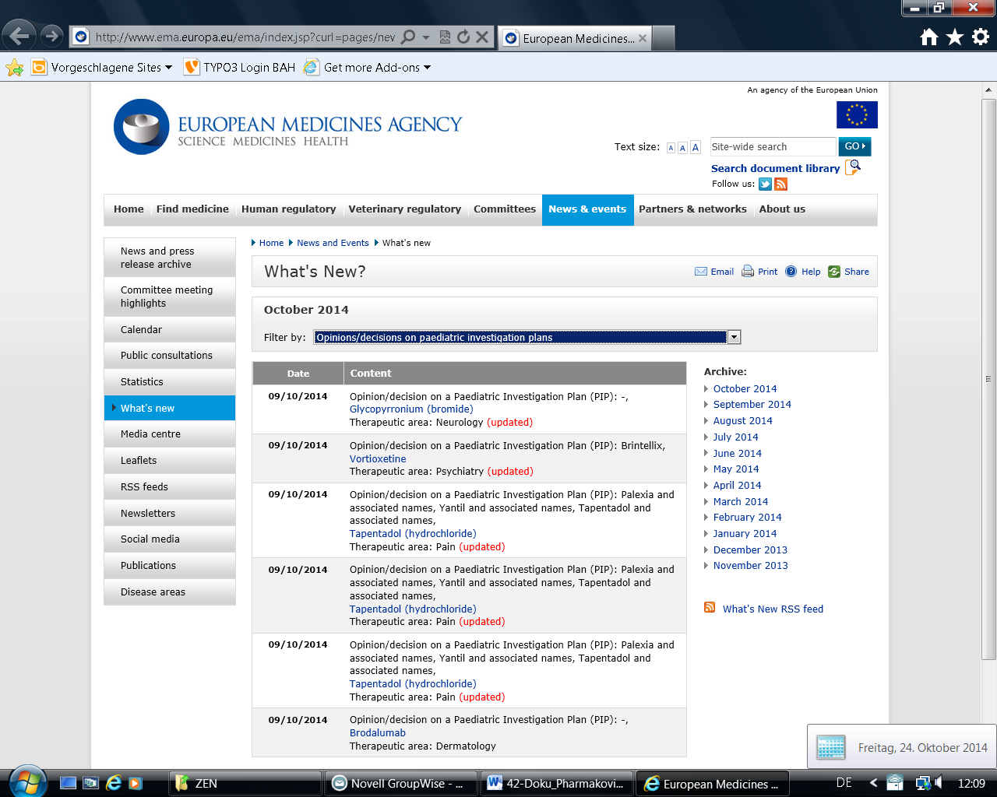
PIP
REFERRALS
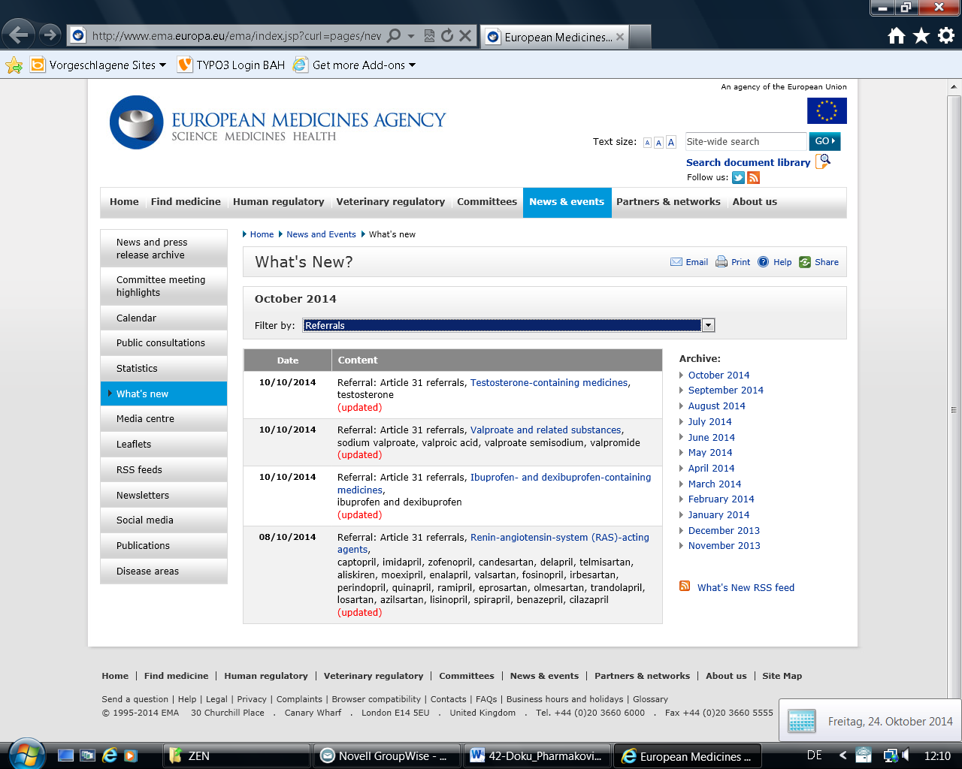
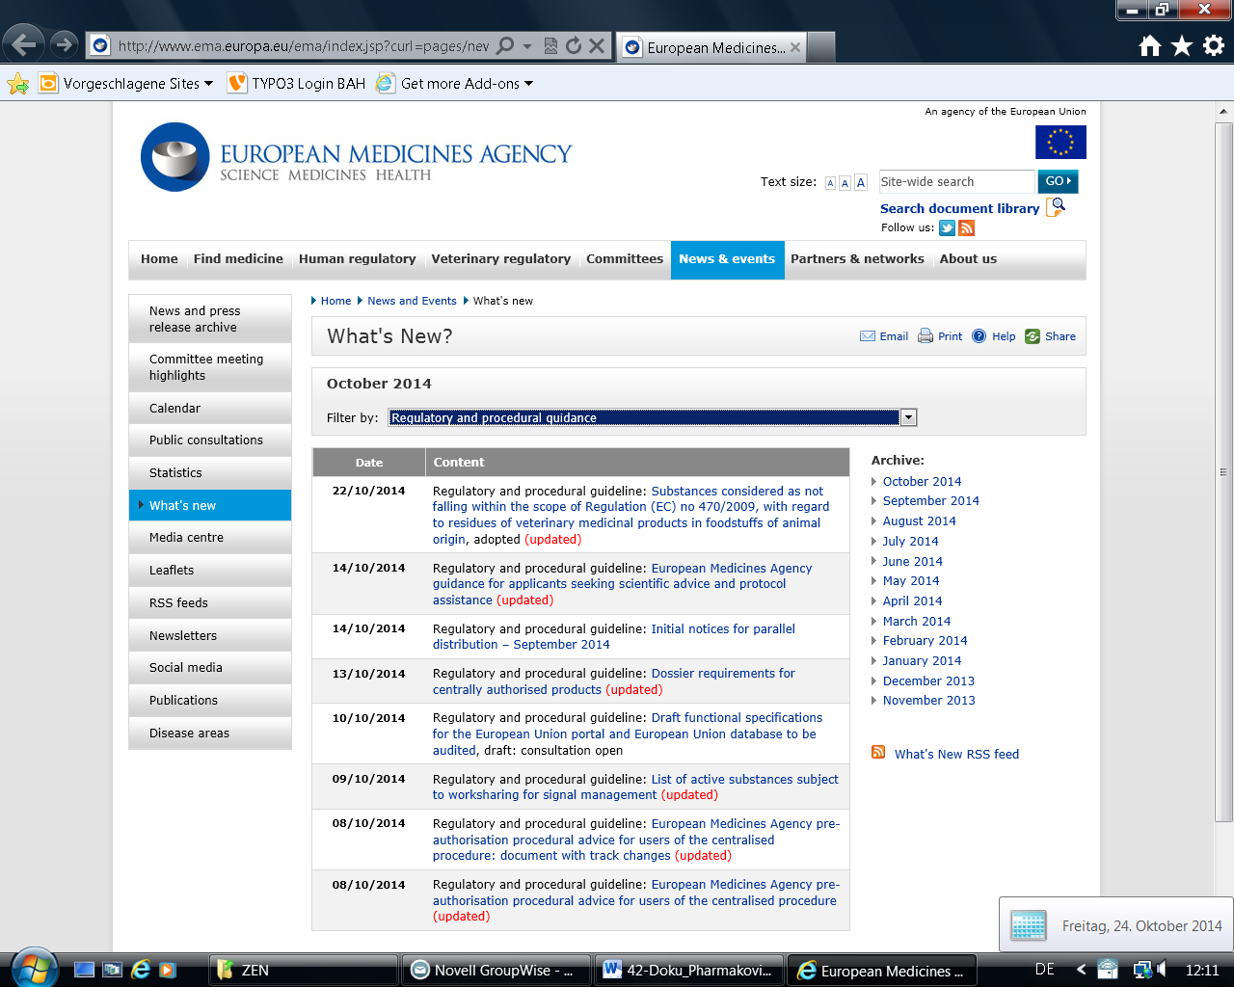
REGULATORY AND PROCEDURAL GUIDANCE

EMA: PSUR Worksharing
http://www.hma.eu/348.html
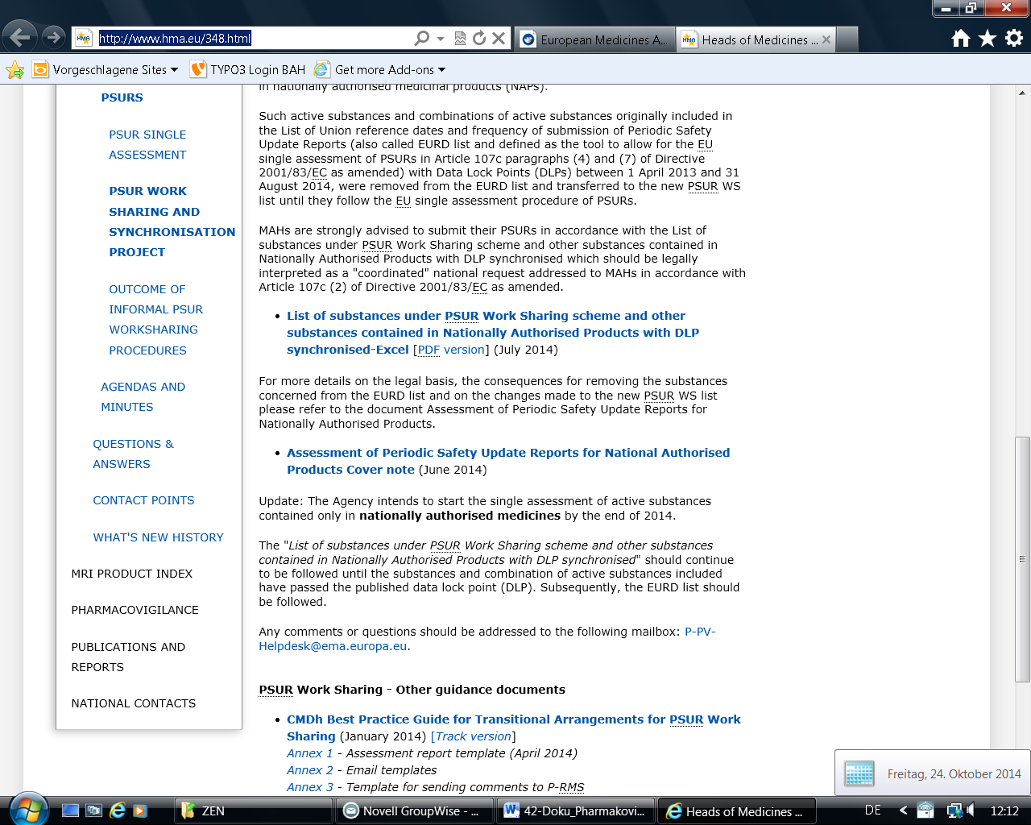

EMA: EURD-Liste
http://www.ema.europa.eu/ema/pages/includes/document/open_document.jsp?webContentId=WC500133159
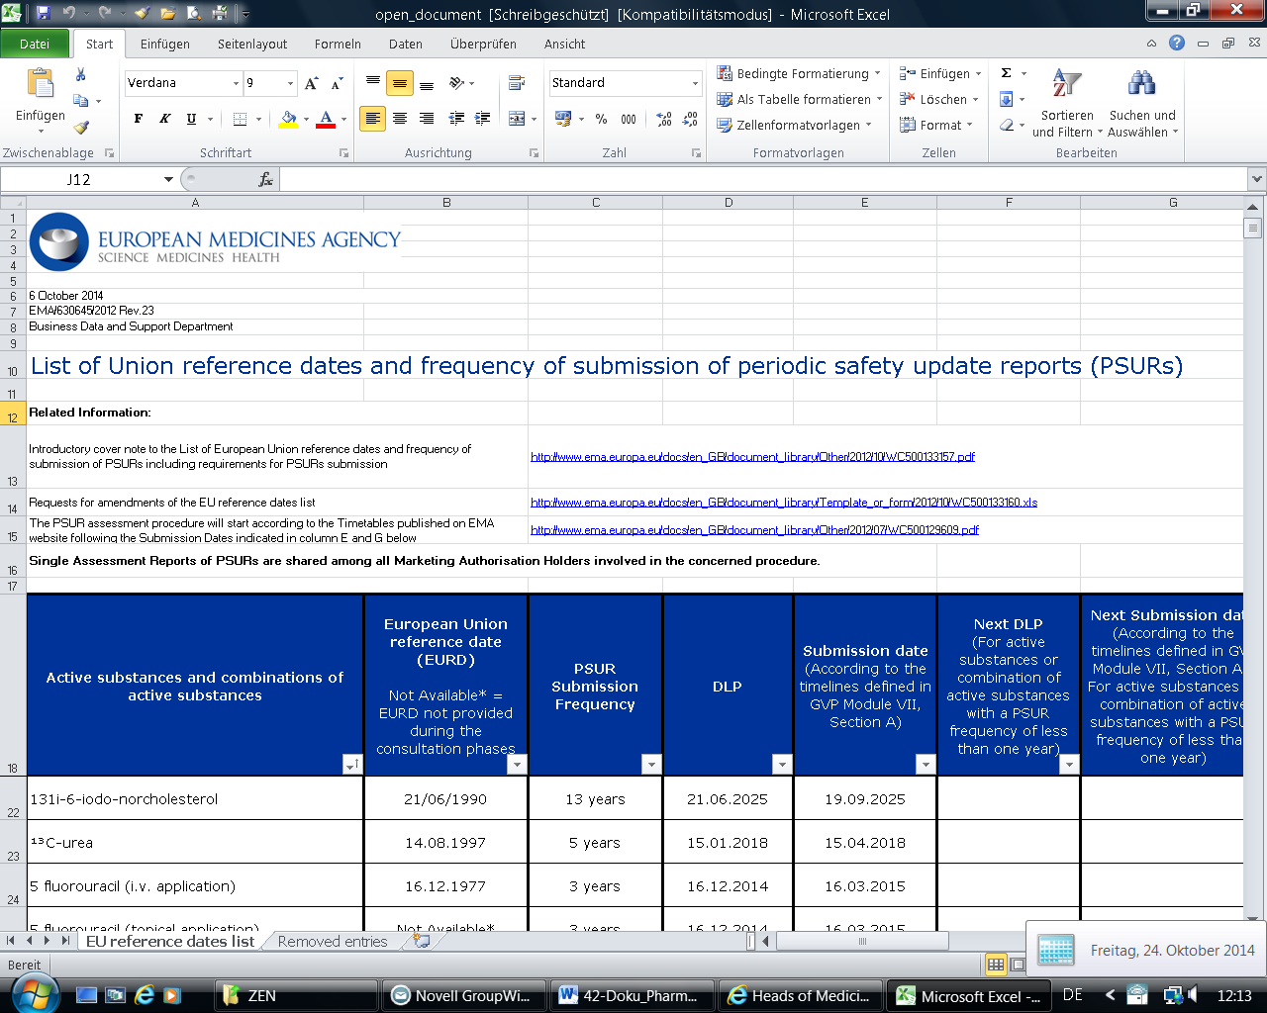

EMA: Additional Monitoring
http://www.ema.europa.eu/ema/pages/includes/document/open_document.jsp?webContentId=WC500144468
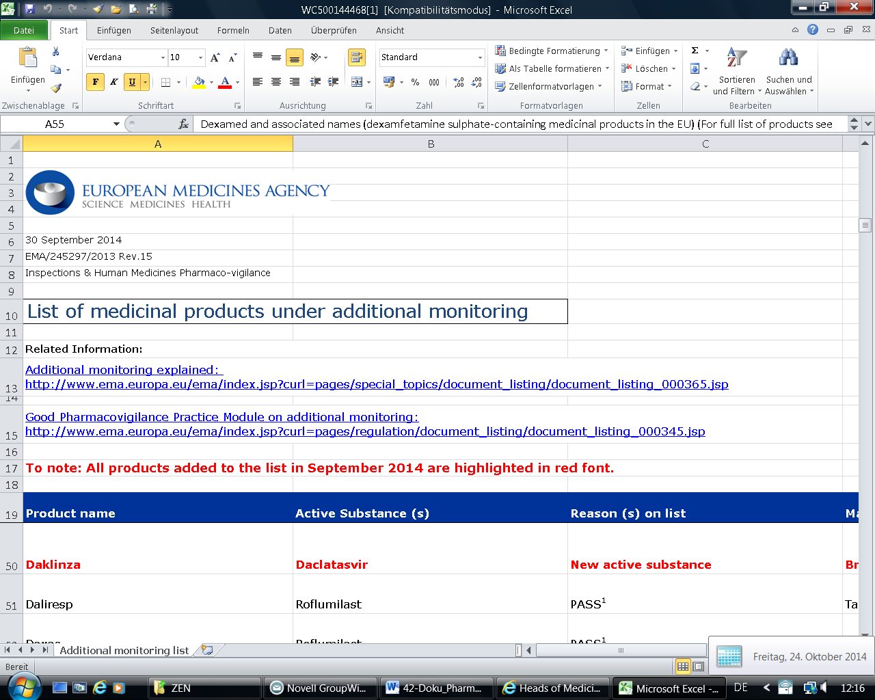

EMA: Signale
http://www.ema.europa.eu/ema/index.jsp?curl=pages/regulation/document_listing/document_listing_000375.jsp&mid=WC0b01ac0580727d1c
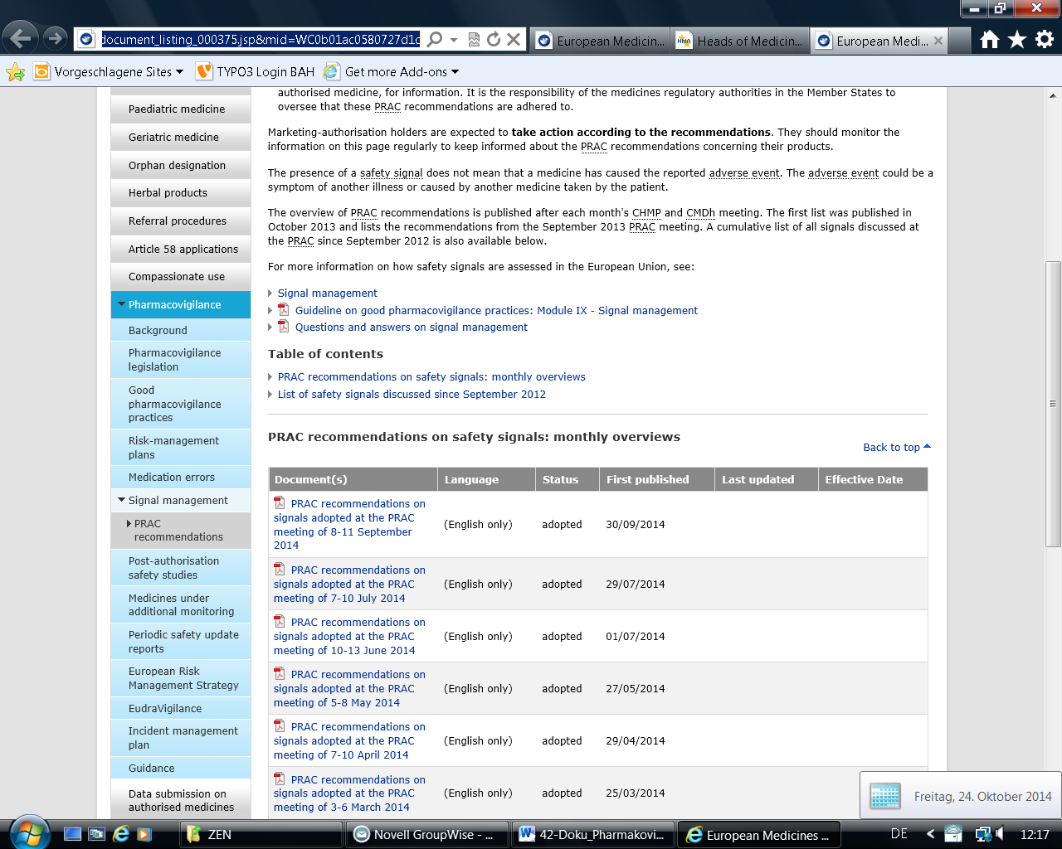

PRAC: Agenden, minutes and highlights
http://www.ema.europa.eu/ema/index.jsp?curl=pages/about_us/document_listing/document_listing_000353.jsp&mid=WC0b01ac05805a21cf
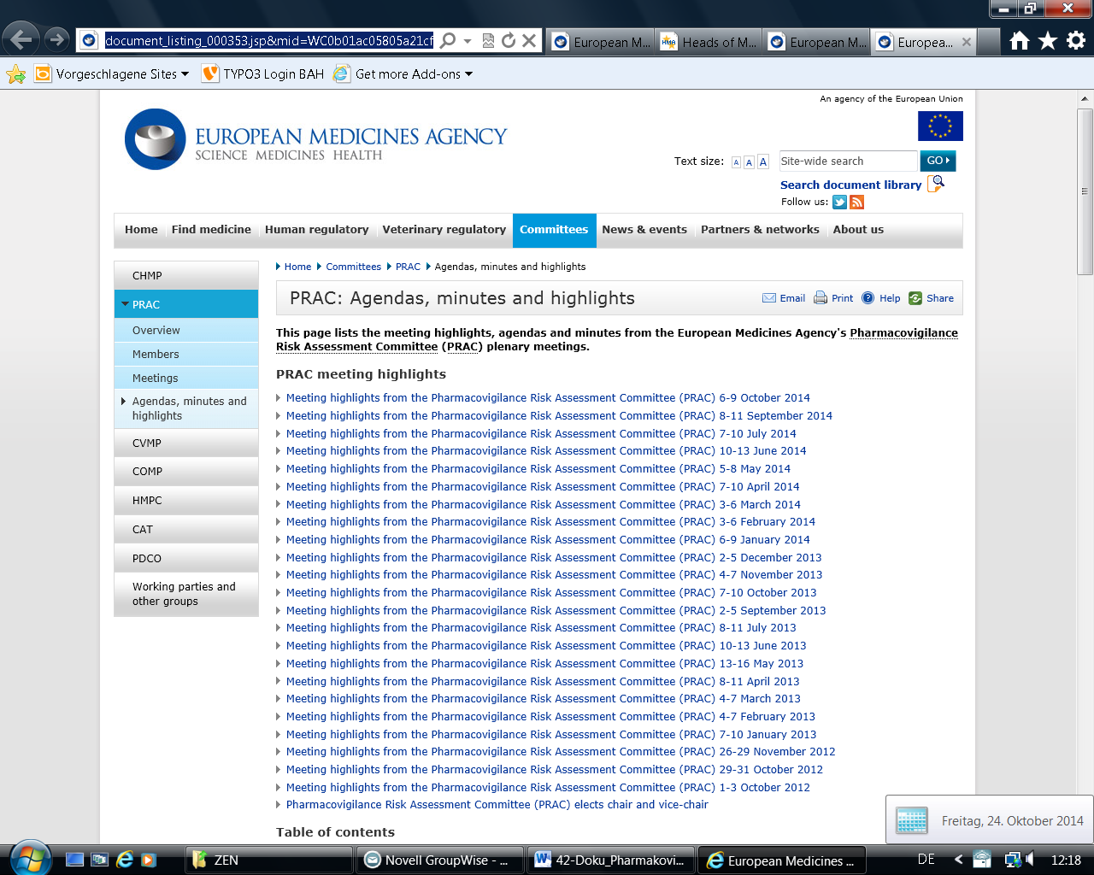

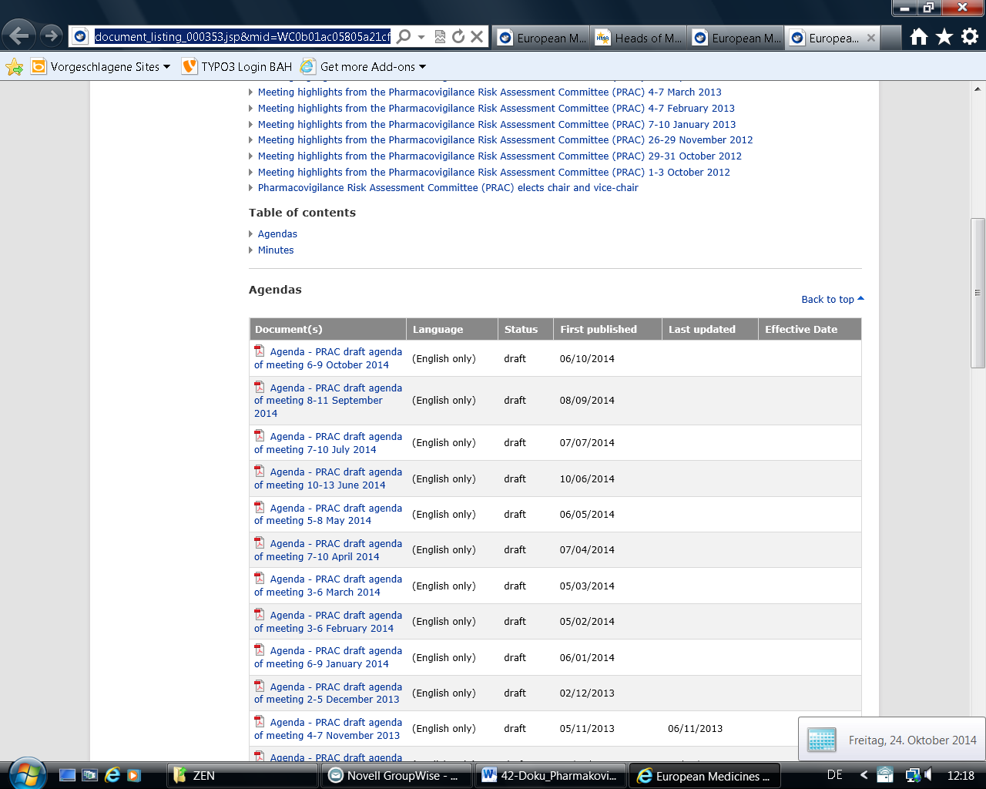

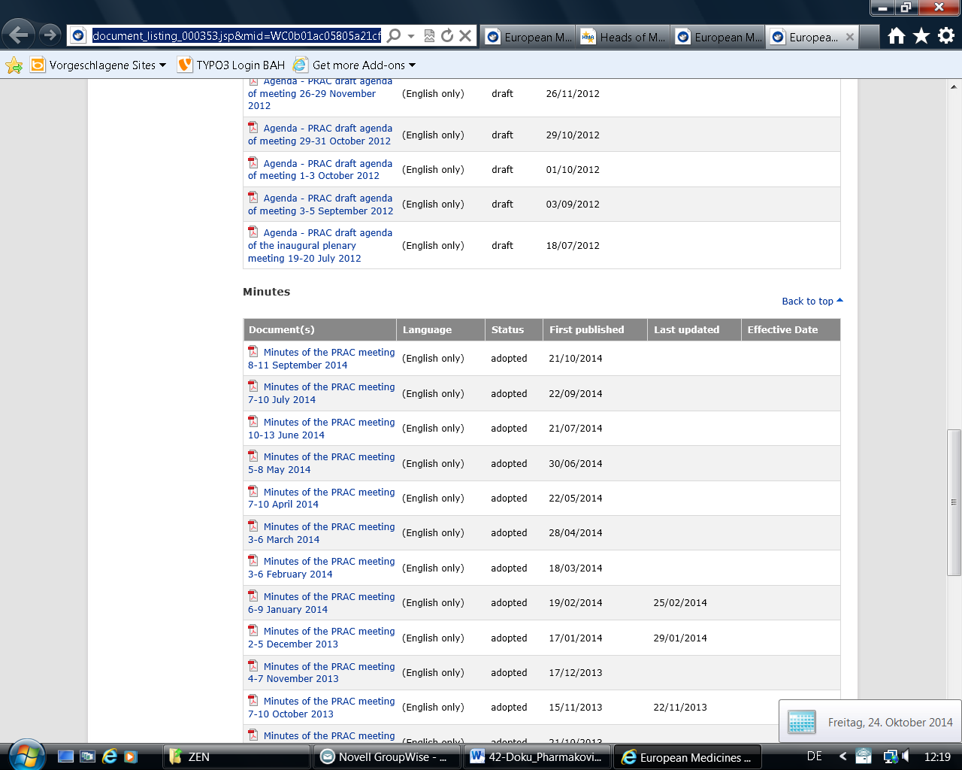

CHMP: Committee meeting reports
http://www.ema.europa.eu/ema/index.jsp?curl=pages/about_us/document_listing/document_listing_000378.jsp&mid=WC0b01ac0580028d2a

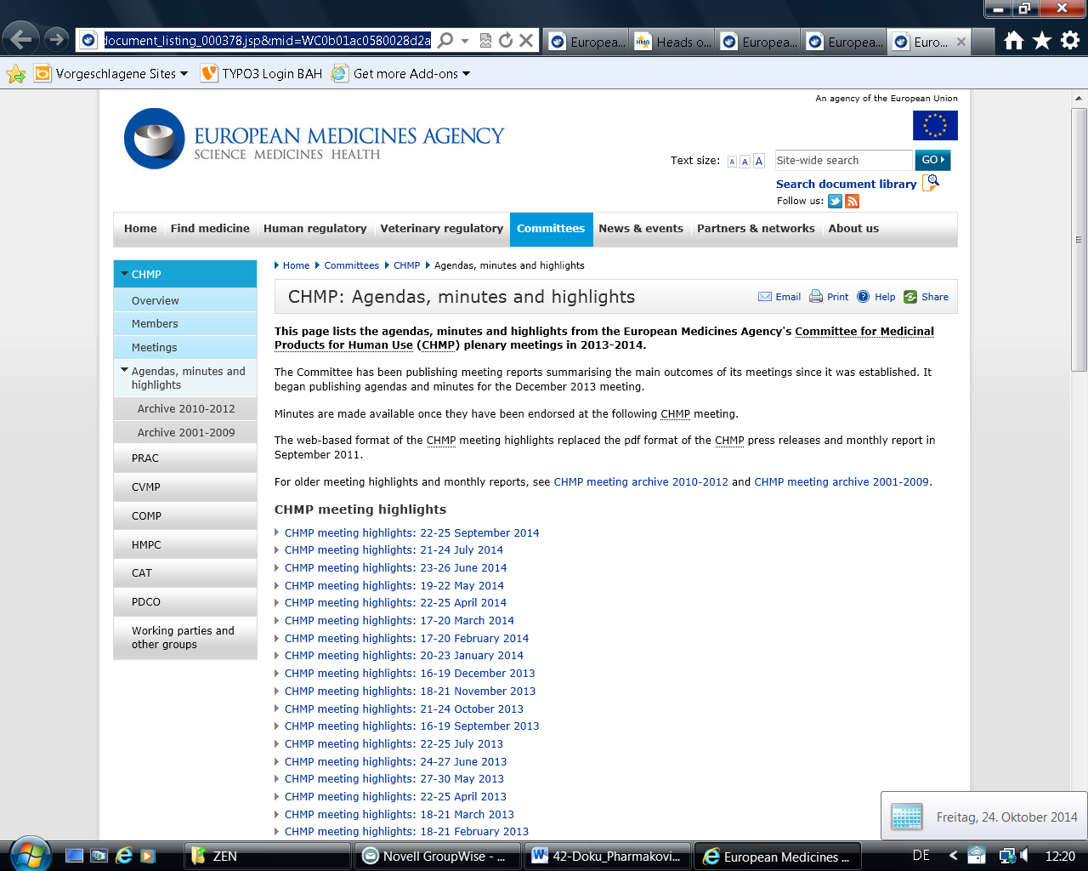

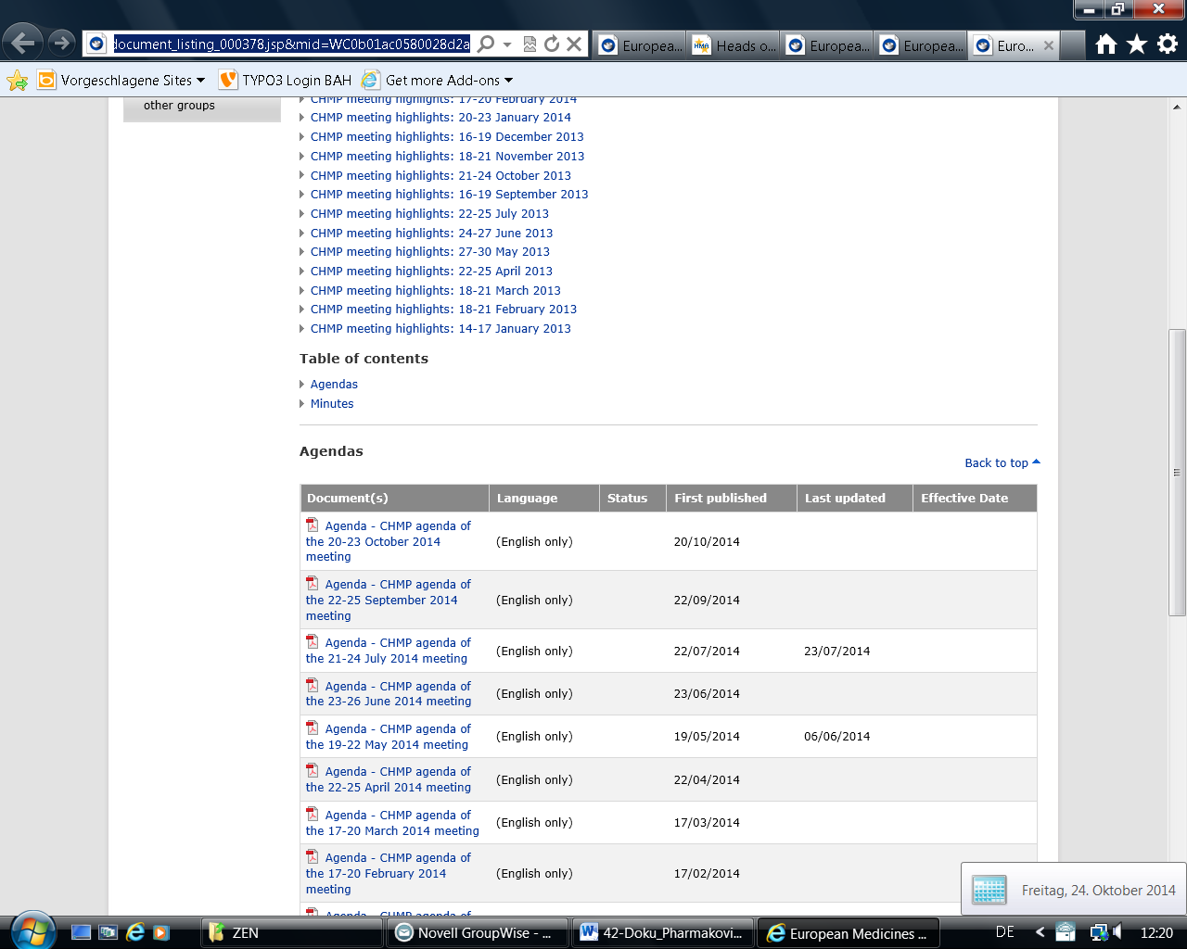
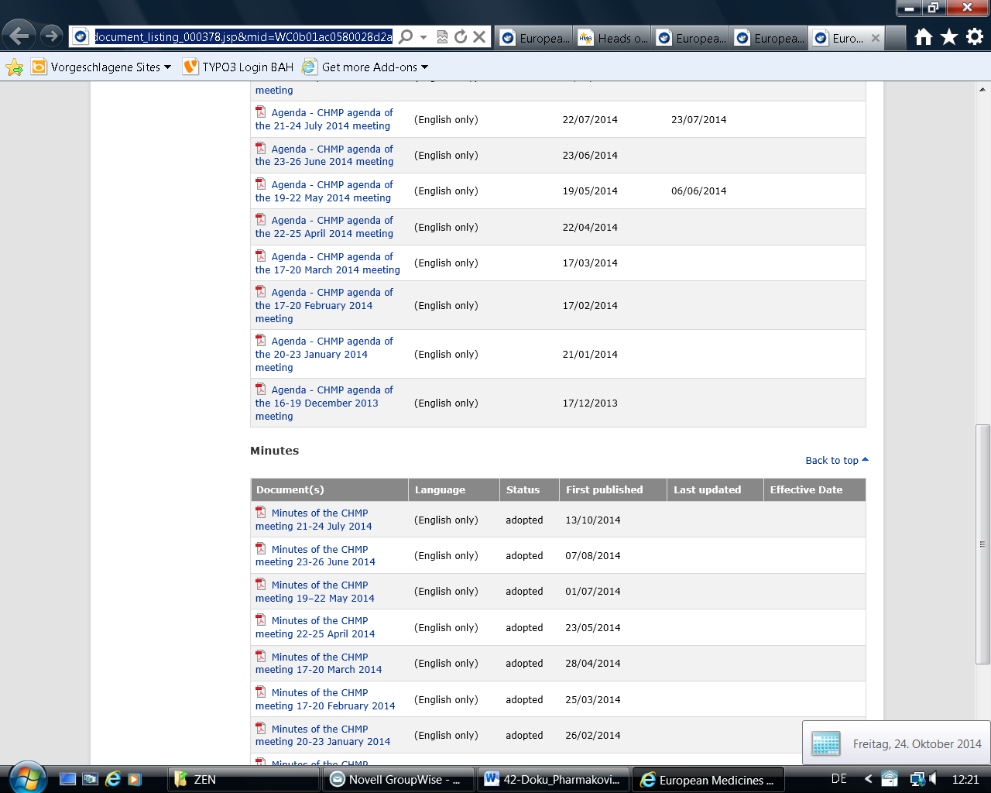
HMA: What’s new?
http://www.hma.eu/186.html#c4864
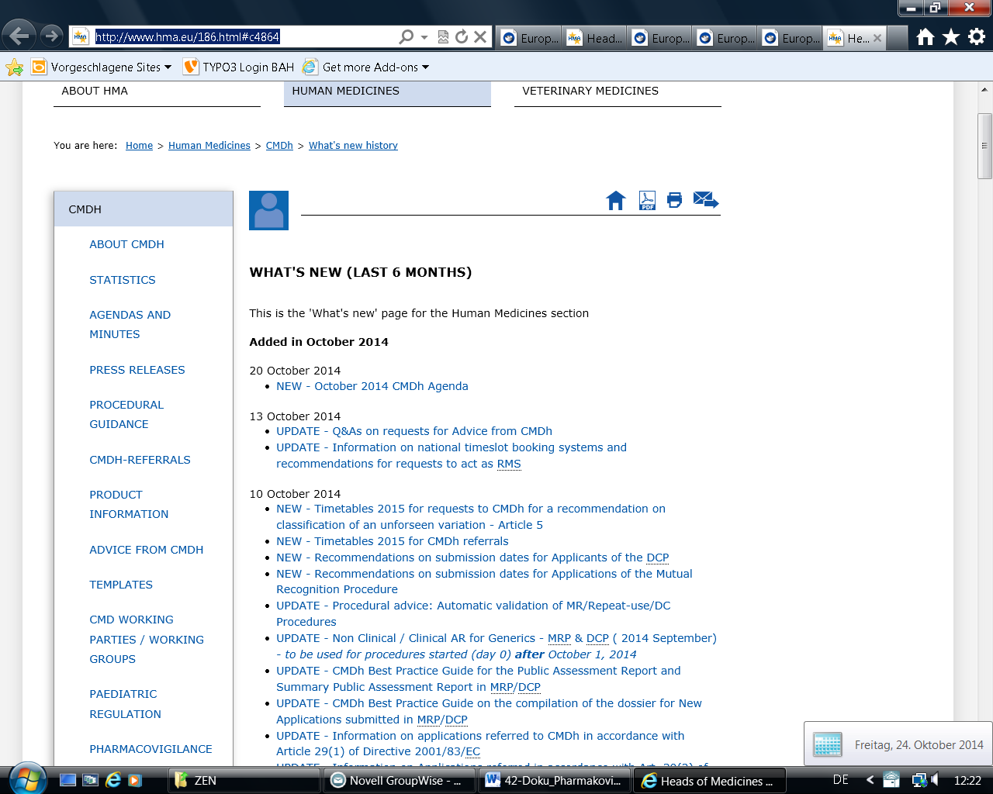

EU-Kommission: Newly adopted Marketing Authorisation Decisions (last six months)
http://ec.europa.eu/health/documents/community-register/html/newproc.htm
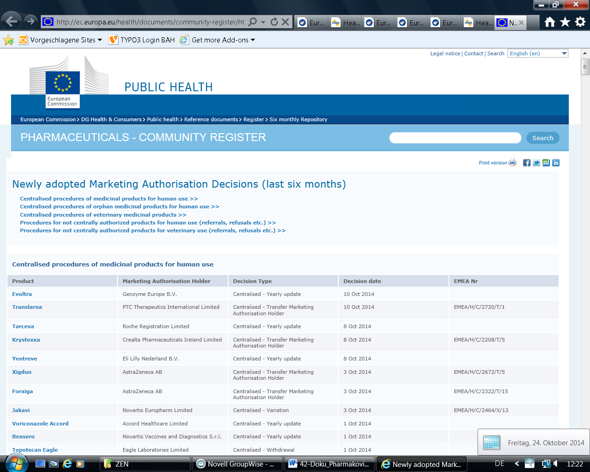

BfArM: Aktuelles (Bereich Pharmakovigilanz)
http://www.bfarm.de/SiteGlobals/Forms/Suche/Service_Formular.html?nn=3494842&sortOrder=score+desc%2C+dateOfIssue_dt+desc&resultsPerPage=15&cl2Categories_Rubrik=pharmakovigilanz
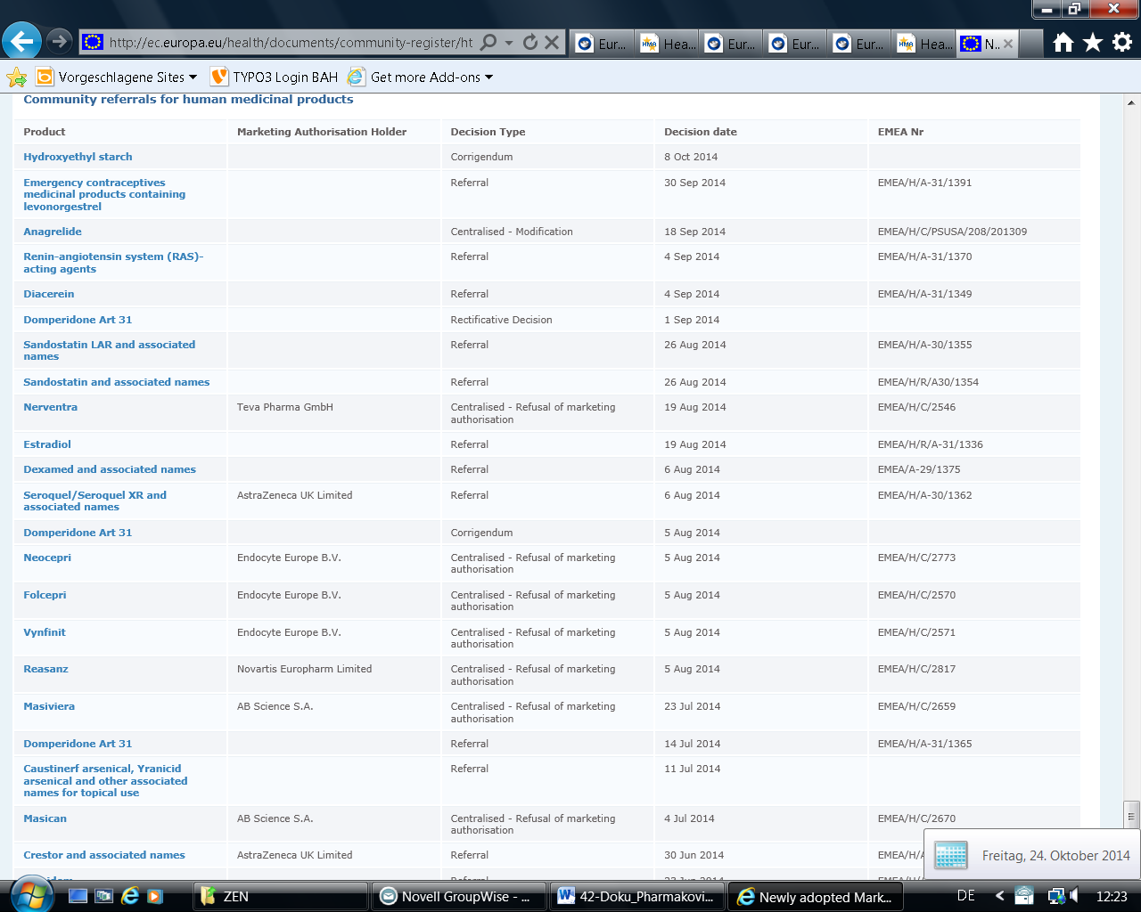

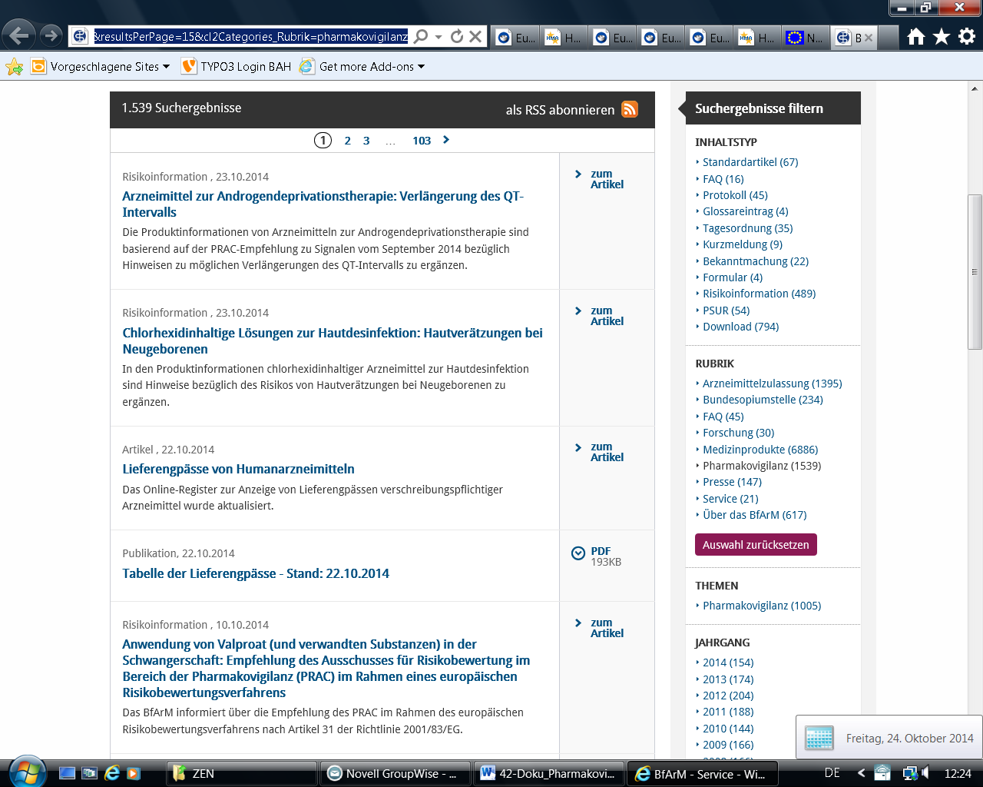

PEI: Aktuelles
http://www.pei.de/DE/service/neue-seiten/neue-seiten-node.html
