Manufacturer Information Form

on Interruption or Discontinuation of Supply of certain medical devices and certain in vitro diagnostic medical devices

(as per Article 10a of Regulation (EU) 2024/1860 amending Regulation (EU) 2017/745 and Regulation (EU) 2017/746)

Note: this form should be completed where reporting on individual or several devices. For reporting on several devices, only one form should be completed and see section 6 for further instruction.

1 Administrative information
Name of National Competent Authority (NCA) to which this report is sent

Type of information
- Initial information
- Additional information (voluntary)
- Follow-up information (voluntary)

Please specify modified sections of the form:

Date of information
Reference number assigned by the manufacturer (if any)
Reference number assigned by NCA (as applicable)

2 Information on submitter of the report

Status of submitter
- Manufacturer
- Authorised Representative (if mandated to act on behalf of the manufacturer)
- Other entity (if acting on behalf of the manufacturer)

3 Manufacturer Information
Manufacturer organisation name
Single registration number (if filled and already EUDAMED registered, please leave following fields in this section 3 open)
Address
Postcode | City
Phone | Fax
E-mail | Country

4 Authorised Representative Information (if applicable)

Authorised representative organisation name (if mandated to make this report on behalf of the manufacturer)
Single registration number (if filled here and already EUDAMED registered, please leave following fields in this section 4 open)
Address
Postcode | City
Phone | Fax
E-mail | Country
5 Other entity (if applicable)

Organisation (if completing this report on behalf of the manufacturer)
Address
Postcode | City
Phone | Fax
E-mail | Country

6 Medical device information

Risk class of device

MDD/AIMDD IVDD
AIMD Active implant
MDD Class III IVD Annex II List A
MDD Class IIb IVD Annex II List B
MDD Class IIa IVD for self-testing
MDD Class I IVD general
MDD Class I sterile
MDD Class I measuring function
MDR |  | IVDR
Class III |  | Class D
Class IIb |  | Class C
Class IIa  Class I  Class I sterile  Class I measuring function  Class I reusable surgical instruments |  | Class B  Class A  Class A sterile

Device Identification
Please fill this section when reporting on an individual device.
Where reporting on several devices, complete the ‘Device Identification – Annex Table’
Unique Device Identification (UDI-DI)/EUDAMED ID (if applicable)
Basic UDI-DI/Eudamed-DI (if applicable)

If the above UDI section is completed and the device is already registered in EUDAMED, please leave the following fields blank
and go to Intended use field.
If filling out the following fields for devices without UDI-DI/ EUDAMED DI, please complete all mandatory fields

Model | Catalogue/reference number
Nomenclature system (e.g. EMDN) | Nomenclature code
Nomenclature text
Commercial name/ brand name / proprietary or common name
Intended use according to the IFU or add IFU in attachment (voluntary)

7 Description of the Interruption or discontinuation of supply (information requested as per art 10a)
Reason for the Interruption or Discontinuation of Supply

- Interruption

- Discontinuation

please select:

Regulatory issue
Supply chain issue
Manufacturing issue
Other
Specify other:

Additional information on reason for the interruption or discontinuation of supply (voluntary)

Information on the assessment of the situation (If available)

Device used in a serious, acute or chronic pathology, life- sustaining or life-saving device or accessory
Intended for a specific population (e.g., vulnerable populations such as paediatric or geriatric patients)
Disruption or interruption limiting / preventing the patients from accessing treatment
Device without or with limited available alternatives, or consumable device not replaceable by any other type/brand
Major market share or in one or several members states
Other
Additional information on the assessment of the situation (if available)

Duration for interruption

When is the interruption /discontinuation of supply estimated to start?

What is the interruption estimated to end (voluntary)?

Additional information about the estimated duration, if the start and the duration is disclosed (voluntary):

Estimated point in time for resumption of supply of the devices (where known and appropriate)

The medical device is usually marketed and supplied to the following countries: (voluntary)
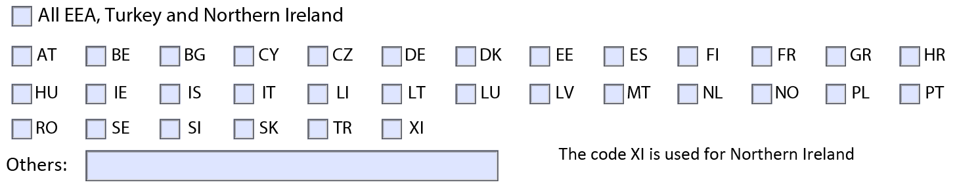

The countries that are impacted by the interruption/discontinuation:
Information Notification(s) regarding the interruption or discontinuation of supply have been sent:

Notification to HCPS Yes No Not Applicable Date Sent _DD/MM/YY
Notification to AR Yes No Not Applicable Date Sent _DD/MM/YY
Notification to importers Yes No Not Applicable Date Sent _DD/MM/YY
Notification to distributors Yes No Not Applicable Date Sent _DD/MM/YY

Attached files (Voluntary)

8 Additional information on Interruption or Discontinuation of Supply (Voluntary)
This section allows manufacturer, on voluntary basis or on the request of a competent authority, to share additional information
Possible mitigations measures: to reduce the impact of the interruption or discontinuation of supply.

Is the redistribution of EU or Global stocks an option? Yes No

Do you manufacture a similar alternative product with a similar intended purpose? Yes No

Details of the remaining inventory / existing stock level At EU level (voluntary)

If applicable, please provide information in attached file (voluntary)
Progress update on the interruption or discontinuation of supply (voluntary)

