JICF survey on the HERA Stakeholders' HUB
Fields marked with * are mandatory.

The project is initiated in response to the “Communication on addressing medicine shortages in the EU” (Ref. COM(2023) 672 final) whereby, DG HERA has been mandated to develop a matchmaking platform in the form of a HERA Industry Stakeholders' Hub.

Scope and objectives: The HERA industry Stakeholders' HUB will serve as a secure ecosystem for stakeholders to engage with HERA and other partners; it envisages the following capabilities:

For the external stakeholders, to directly contact DG HERA via a single channel (e.g. from meeting request to advice on the access to necessary funds and policy measures)
For all stakeholders, to access and share information in secure workspaces such as for example on innovative projects in the area of Medical Counter Measures (MCMs)
For economic operators, to identify and build new industrial partnership in the area of MCMs For Critical Medicines Alliance and Joint Industrial Cooperation Forum (JICF) members, to
interact in a secure environment
For DG HERA, to triage stakeholders’ request, manage stakeholders cooperations and meetings, gather insights and knowledge and information on critical manufacturers capacities, operations and cooperations
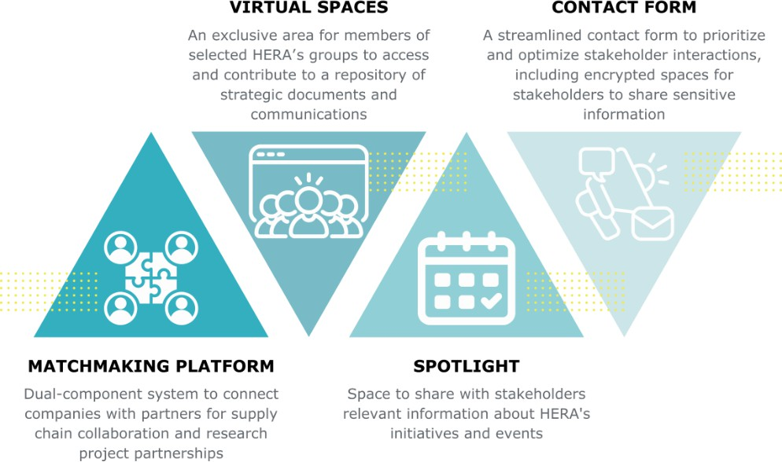

Matchmaking Functionality

The objective of the matchmaking platform is to connect partners along the supply chain and to facilitate the research project partnerships. The platform will allow the companies to register their data and choose what information is available to other members of the matchmaking platform.

  - What profile should the matchmaking platform have?
General matchmaking platform where economic operators can look for partners along the supply chain or research partners.
Targeted and need based matchmaking. It should be linked to a priority list of pathogens and the specific MCM strategies.
Need based matchmaking which will be activated in a response to specific needs and specific events.

  - What features should the matchmaking functionality have to assist you in searching for supply chain or research partners?

  - What challenges or limitations we should consider when using the HERA Matchmaking Platform for finding new business partners along the supply chain?

  - How can we ensure the platform reaches all relevant operators, ensuring sufficient market penetration?

  - How should the matchmaking work?
Companies looking for a partner will need to submit an anonymized request. The seeker would produce a 'non confidential part' which would be completely accessible and visible by other registered users in the matchmaking component. In addition, the requester would need to fill in additional info which will be entirely confidential and never disclosed. Based on the additional information and the general request an alert will be pushed to suitable candidate/interested partners as a notification that a possible partnership is identified pointing to the general non confidential part (the criteria under which those notification will be dispatched would be confidential and not shared). The recipient can respond to the request and seek additional info
/contact etc. The seeker can pursue the expression of interest and decide to engage/share the info they want.
Companies looking for a partner should be able to search the database based on information included by each company that signed up to the matchmaking and directly contact the companies they are interested in matchmaking with.
Both of the above Other

  - If other, please specify:

  - What specific selection criteria should be implemented to ensure a high-quality matchmaking process? The organisation will have a matchmaking profile, so other participants in the matchmaking platform can search for them. There are different possible search options: one via a map, second following a search

description, third when an organisation is looking for matches to a request. The information on the matchmaking profile will be used in the searches.
What information(/filters) should the matchmaking profile have? For example: Industrial Sector / Activity, Product Categories, Location, etc
Should any of this information be restricted? For example, some fields could be available when searching on a map while some restricted fields only when interest for a request is confirmed from both parties.

  - How the specific company profile should be managed? The HERA Stakeholder HUB will be designed to allow companies to self-manage the membership of their organisations in the portal. There is an admin role, who can add members, and a member role who participates in the portal activities. For the matchmaking platform, can any member of the company participate? Do we need a dedicated role to be given to the company members who can access the matchmaking platform on behalf of the organisation?

  - Only certain organisations will be able to access the matchmaking platform. Access will be granted based on the type of the organisation (we are using the EMA SPOR organisation type classification). Which types of organisations should be allowed? We intend to grant access to all economic operators.
SPOR organisation type classification: Educational Institution
Health care
Patient organisation/association Hospital/Clinic/Other health care facility Laboratory/Research/Testing facility Healthcare payer
Industry
Pharmaceutical company
Non-Pharmaceutical company Pharmaceutical association/federation Not-for-profit
Regularity Authority
Member State Institution/Body/Agency EU Institution/Body/Agency
Non EU Institution/Body/Agency EEA National Competent authority
Non-EEA National Competent authority Ethics Committee
SME
Micro Small Medium
Not Applicable
Other EEA National Competent Authorities

JICF Collaboration Space

  - What features should the JICF Workspace have?

  - What features should be included in these spaces to foster a collaborative environment for sharing best practices and insights?

  - What strategic documents and communications would be most valuable for you to access in the collaboration spaces?

Contact Form

  - The contact form will have a feature of a secure channel/room where companies will be able to directly contact HERA. Each company will have a separate, dedicated channel for the exchanges with HERA. It will be a secure space where all integrations with specific companies will be kept in one place. What features should each secure space have to provide a user-friendly and useful tool?

Other

  - How can we continuously improve the HUB's features through effective feedback mechanisms?

  - What additional functionalities would you like to see added to the HUB in the future?

  - General Comments

General Information

The attached privacy notice explains how we use any personal information we ask you for when completing this form.

- 5.1 Prefix/title

- 5.2 First Name

- 5.3 Last name

- 5.4 Single Choice Question
Country (EU/EEA) Organisation
Company
European Commission Other

  - Please specify your affiliation

  - Please specify your country

  - Please specify the Department you are working at.

- 5.8 Function/ Job title

- 5.9 Email

Data processing and general comments

I hereby confirm that I have read and understood the Privacy statement
Privacy_Statement.pdf

- 6.1 I hereby confirm that I consent to the collection and processing of my personal data

