MDCG NT WG

Work package 3

Work item 3/1/1

NET WG consultation on Horizon Scanning System – Deadline 10/11/2022
Following the workshop on horizon scanning and the latest NET WG meeting of 17 May 2022, the group agreed to the further development of this document outlining regulators expectation for the future NET WG horizon scanning system.
Following the written input provided on the earlier version of this document (v4) and the discussions which took place on 17 May 2022, an updated version has been formulated.
Ahead of the upcoming NET WG meeting on 18 November 2022, you are kindly requested to provide your contributions to this work stream. Specifically, please provide input on the methodology section, including ways to search for signals, trends and factors in relevant sources using an intelligent search strategy, as well as the search strategy. Additionally, please provide your views on the criteria to be established (currently the former TT matrix has been proposed as the basis) and on Annex II, which explains in more detail the draft criteria.
Kindly respond with your input utilising the commenting table embedded below to nada.alkhayat@Ec.europa.eu with sante-new-technologies@ec.europa.eu and sante-med-dev@ec.europa.eu in cc by 10 November 2022.

MDCG NT WG

Work package 3

Work item 3/1/1

Description

The MDCG horizon scanning system aims to systematically and continuously identify opportunities, risks or other features related to new and emerging technologies which may challenge the EU regulatory system on medical devices and in vitro diagnostic medical devices. This is of pertinence as these features have an impact on:
- patient safety or public health
- the existing legal framework (qualification/classification/clinical/compliance)
- what regulators or notified bodies will have to assess

The system should cover technologies in various stages of development. Signals, trends and factors related to those technologies will undergo a high-level impact analysis. Based on this, decisions will be made on the need to initiate a “deep dive”, i.e. a more detailed analysis with the aim to provide insights on any concrete challenges to the system (see figure 1 in Annex). In addition, the analysis should facilitate the anticipation of future policy needs, including initiatives to support innovators/innovation and to develop expertise among regulators. Depending on the identified topic for the deep dive, it will be decided whether this should be performed by an internal TF in the NET WG, in cooperation with or transferred to another MDCG WG, or outsourced to an external contractor.

Methodology

- Please provide your contributions on methodology section, including ways to search for signals, trends and factors in relevant sources using an intelligent search strategy.

Sources:

- Scientific literature,
- Grey literature,
- (Social) media,
- Innovation office queries from/advice to/meetings with industry/academia,
- Clinical trial/clinical investigation info,
- Vigilance reports,
- Stakeholder meetings/conferences,
- Other Horizon Scanning services,
- Expert panel opinions
- Call topics in Horizon Europe, e.g. under Innovative Health Initiative
- Contributions from national competent authorities
To be considered: Sources of public information at EUDAMED:

Search strategy

- Please provide your contributions on search strategy

Note 1: As part of this strategy, generic as well as specific key words need to be defined and used. As part of an initial pilot for the horizon scanning system, key words based on previous horizon scanning exercises could be used, e.g. chosen from a list of categories of technologies (see Annex II)
Note 2: Considerations on the time horizon/timeline should be included. This will be related with the level of evidence available for a specific technology (see temporary annex)

Criteria for more detailed analysis:
- Need to define and agree on criteria (TT matrix as the basis – please see Annex II including the embedded excel sheet). For your specific attention the screenshots on degree of novelty, market maturity etc. also in Annex II. Kindly provide your views and comments on them.
- Please also provide your input to additional criteria which should be set.

Current criteria:
- Degree of novelty
- Market maturity
- Potential new opportunities
- Potential new risks

Additional suggestions:
A link or platform on Europa website can be used for operators to transmit some questions or request on innovative products.

Annex I

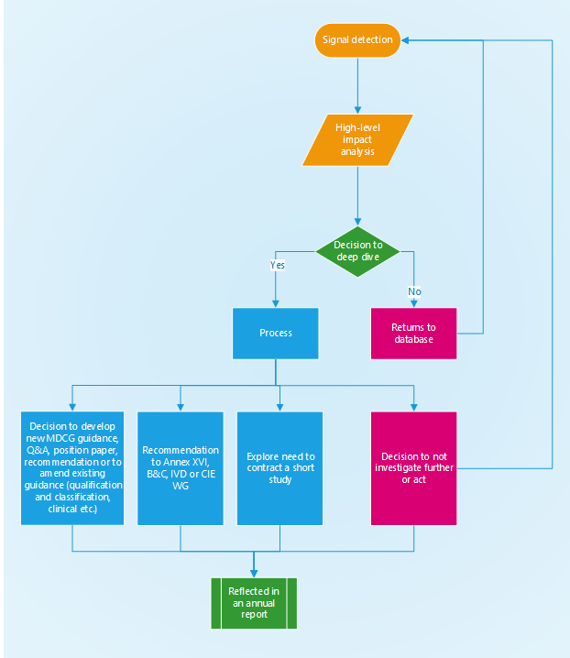

Annex II:

TT matrix:

Categorisation of technologies:

Examples of technologies the NET WG pick up on through previous horizon scanning functions: This section will feed into the search strategy/scope.

Category
Products made using new manufacturing processes, such as 3D printing (custom made and not-custom made devices)
Software/MDSW/ e-Health/AI/Big data applications
Drug Device Combinations
Innovative implants
New imaging technologies
New radiotherapy technologies
Nanotechnology applications
Next Generation Sequencing applications
Annex XVI products
Sensor technology for MDSW

Categories should be reviewed on a defined basis (to be defined).

Market Maturity:
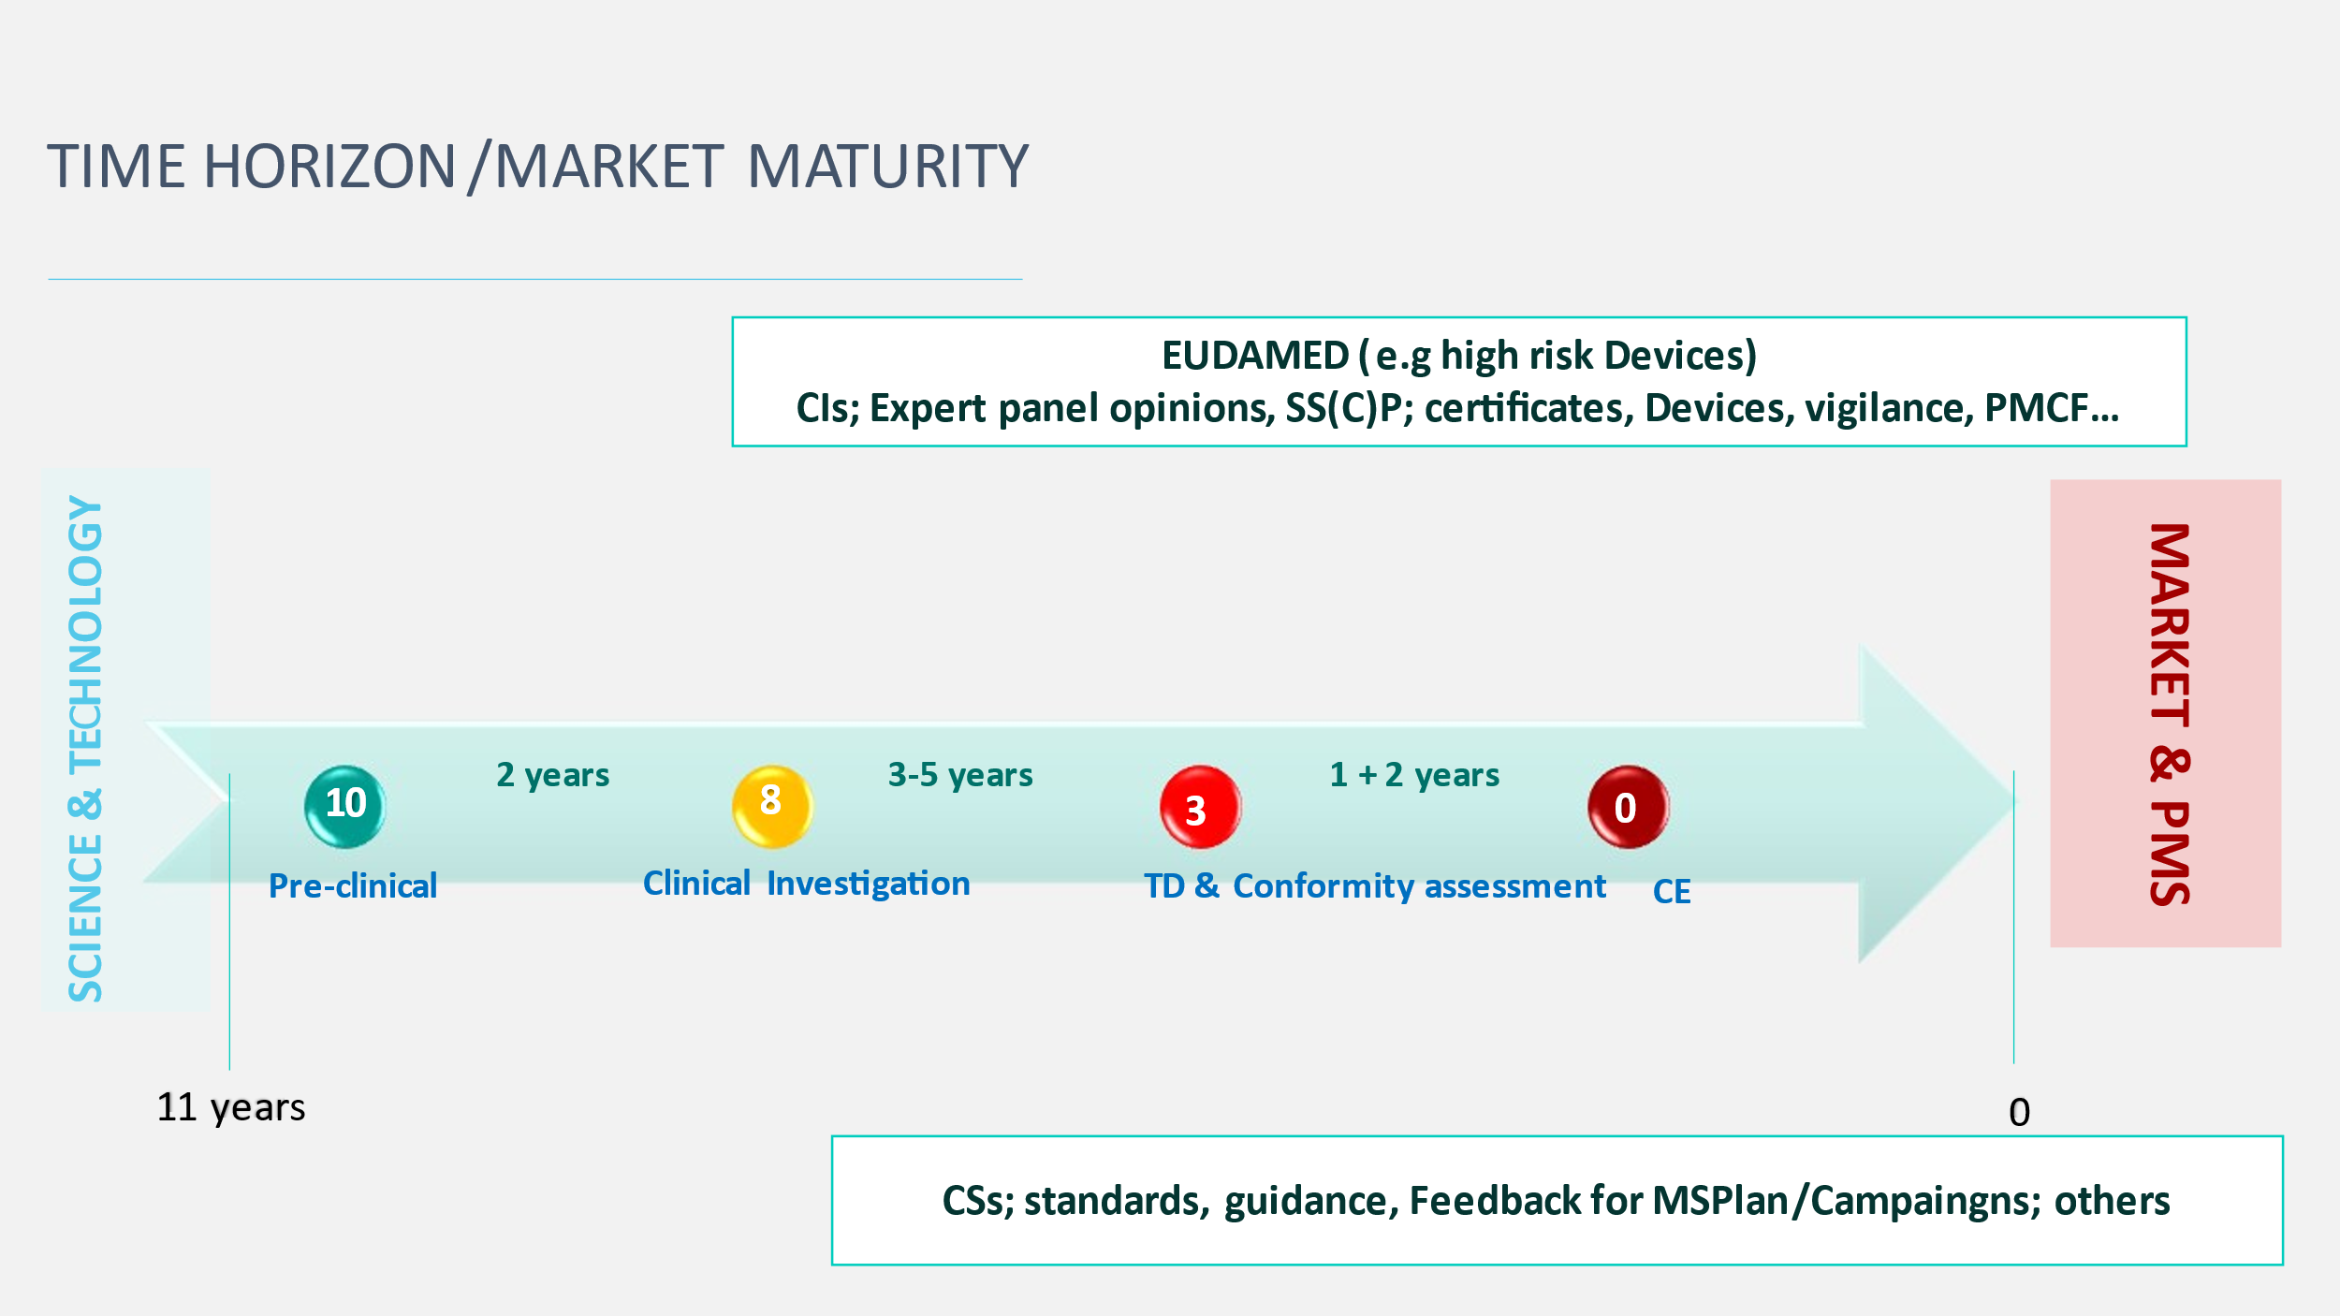

Degree of novelty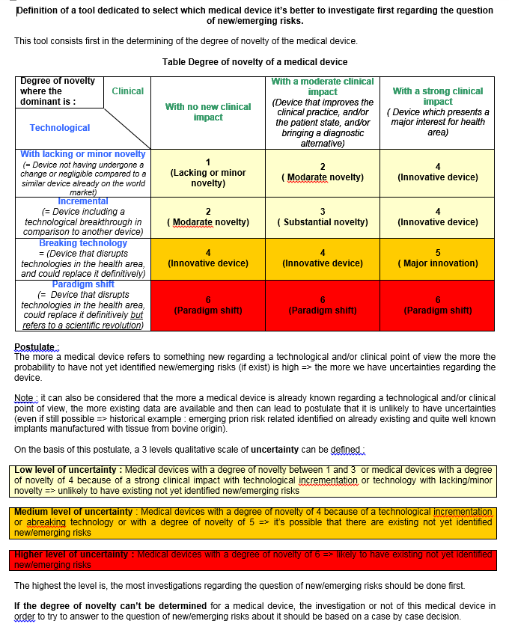

Market maturity
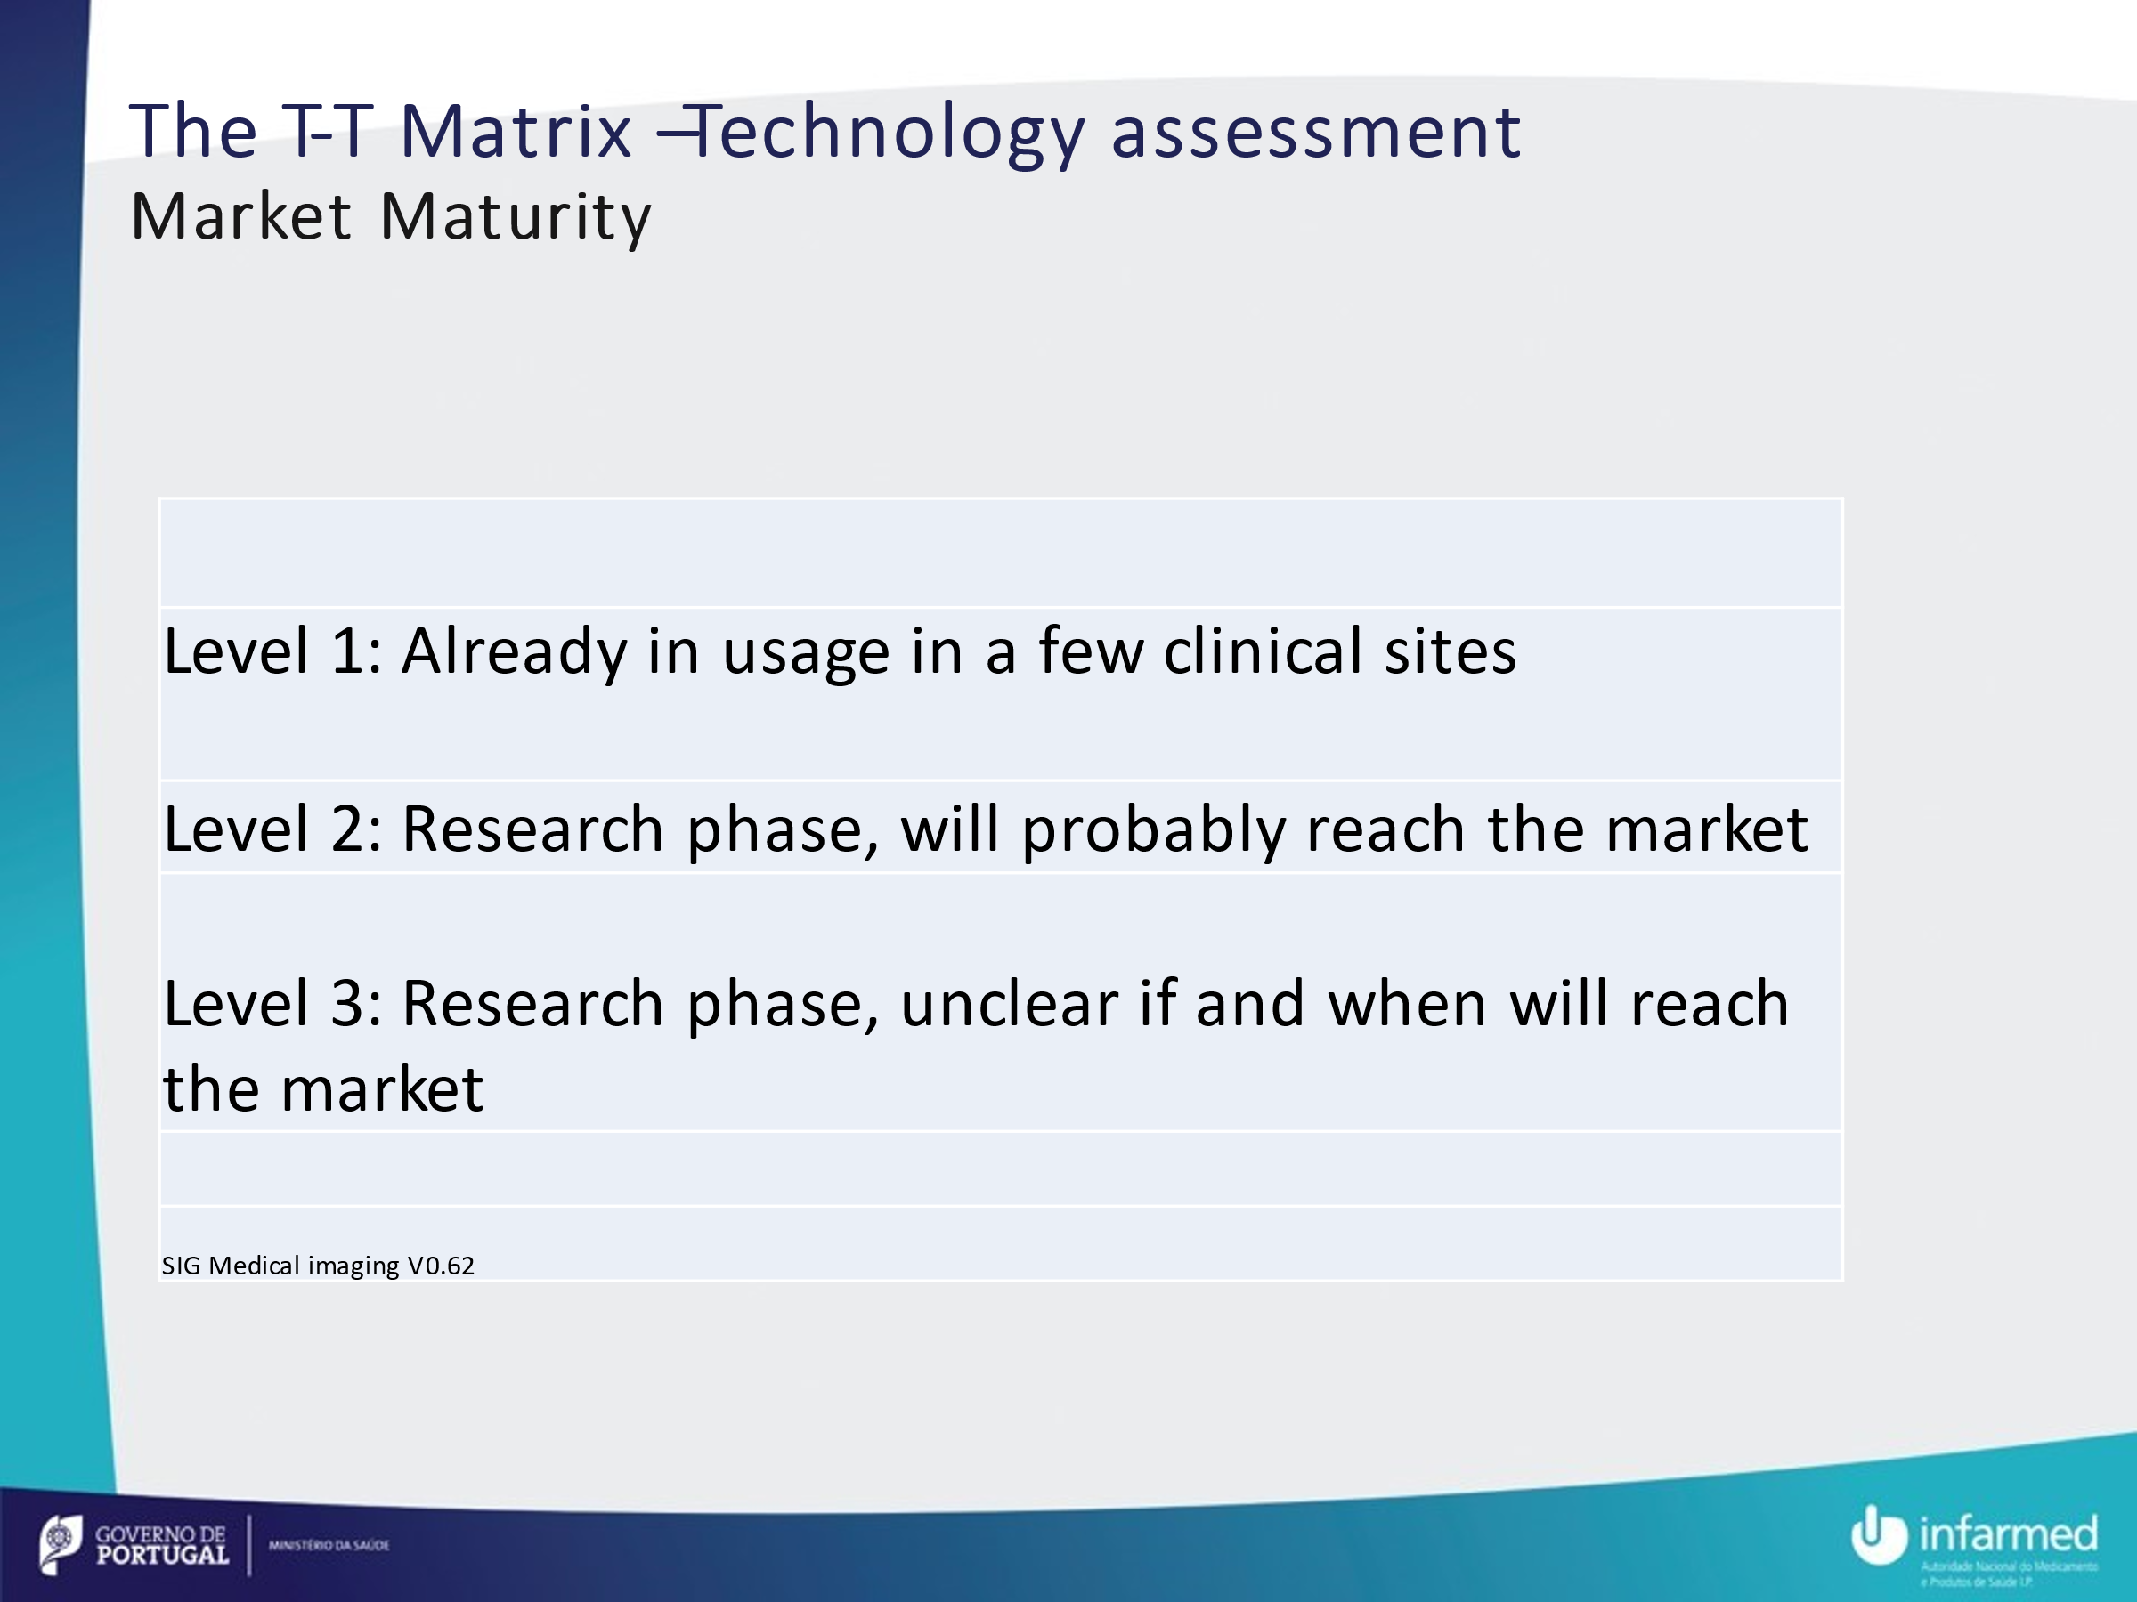

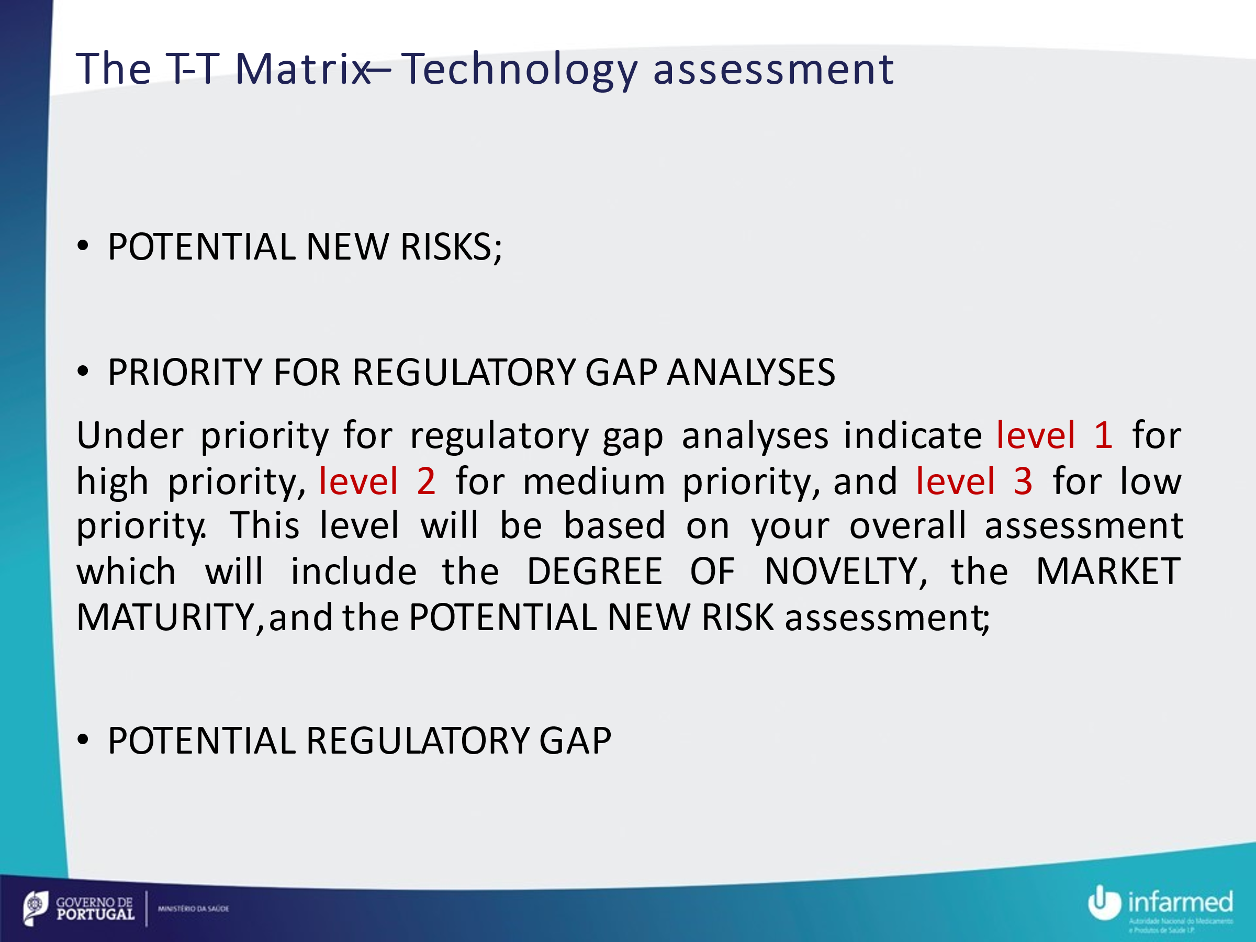

https://en.wikipedia.org/wiki/Grey_literature
https://health.ec.europa.eu/medical-devices-expert-panels_en

